**FLIGHT LANDING**

**By**

**Bernice Somnath**

**UCID: somnatbe**

**CHAPTER - 1**

**Introduction:**

In this chapter, we will focus on cleaning the data and removing the extreme values. Finally we’ll conclude by summarizing them and analyzing their distribution.

**R-Code**

1. **Import the FAA1 file.**

flight <-read.csv("C:/Users/Bernice/Desktop/FAA1.csv",sep=",",h=T)

dim(flight)

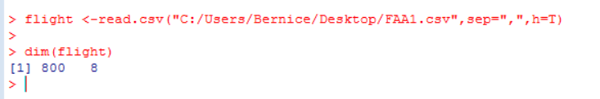

1. **Summarize the data**

summary(flight)

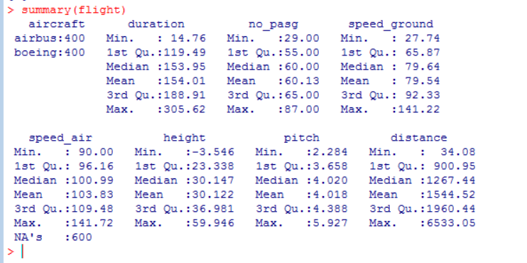

1. **Remove the outliers**

flight_det <- subset(flight, duration >= 40 & speed_ground >= 30 & speed_ground <= 140 & height >= 6 & distance <= 6000)

dim(flight_det)



1. **Summarize the final data for analysis**

summary(flight_det)

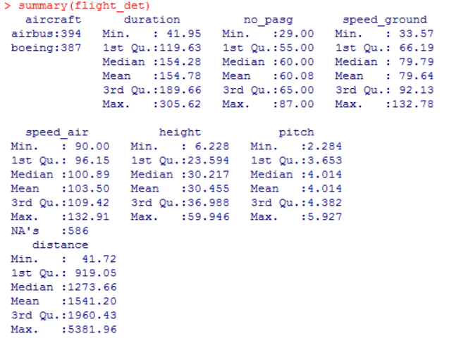

**CHAPTER - 2**

**Introduction:**

In this chapter, we will focus on analyzing and exploring the cleaned data.

**R-Code:**

1. **Plot distance against all the columns**

par(mfrow=c(1,1))

plot(flight_det$distance~flight_det$duration)

plot(flight_det$distance~flight_det$no_pasg)

plot(flight_det$distance~flight_det$speed_ground)

plot(flight_det$distance~flight_det$speed_air)

plot(flight_det$distance~flight_det$height)

plot(flight_det$distance~flight_det$pitch)

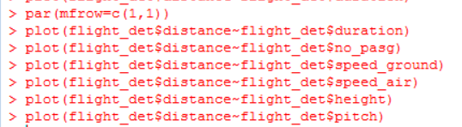

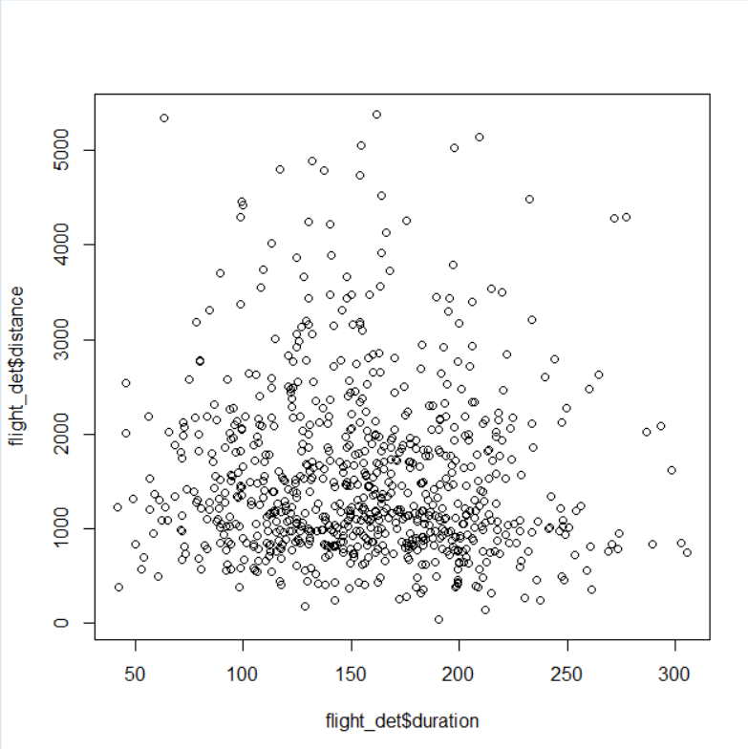 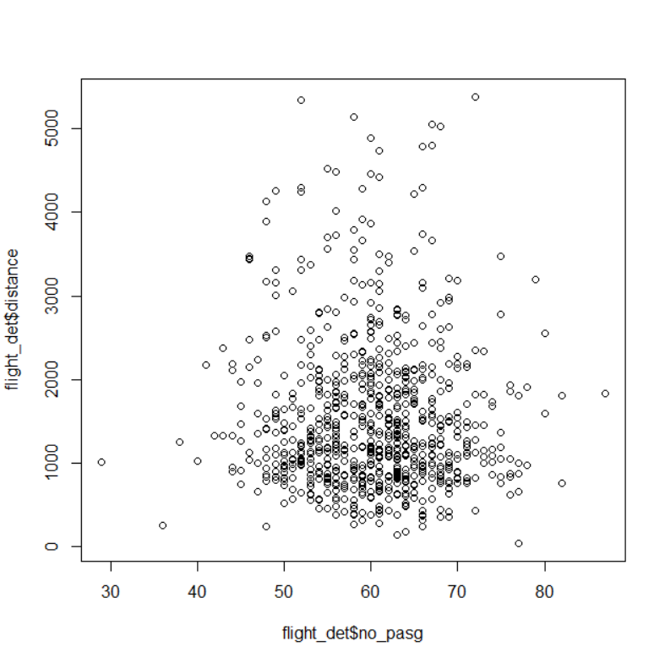

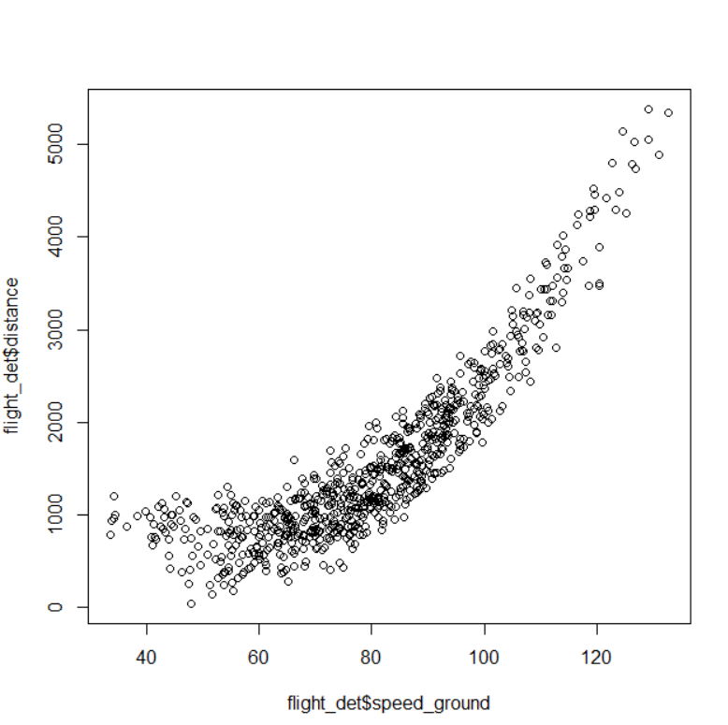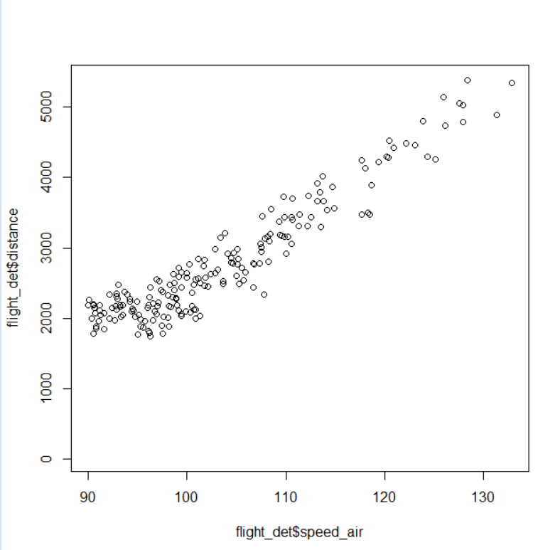

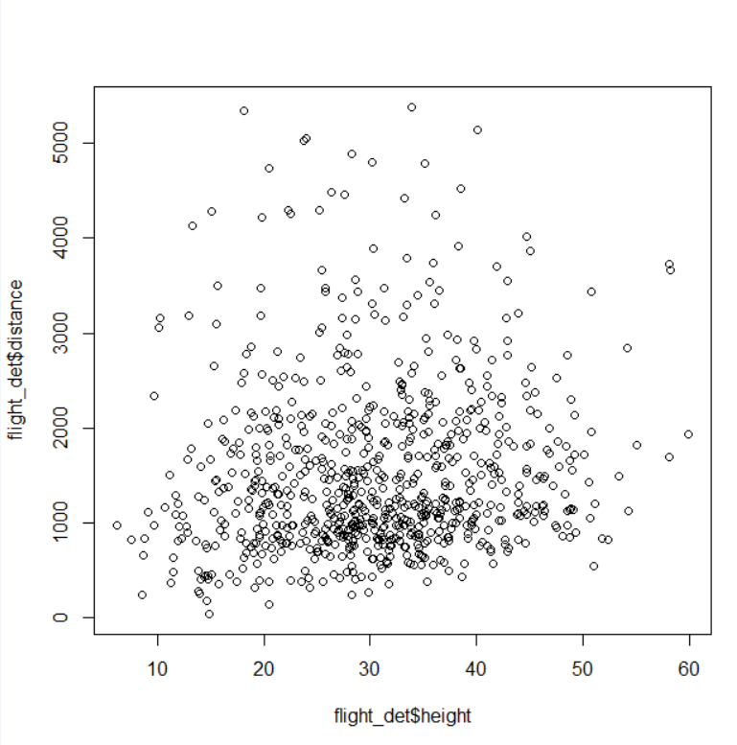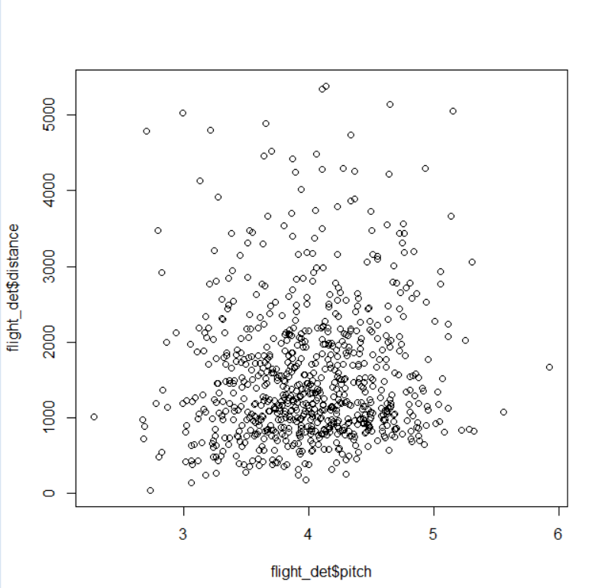

1. **Generate boxplots for visualization**

par(mfrow=c(1,1))

boxplot(duration~aircraft, data=flight_det)

boxplot(no_pasg~aircraft, data=flight_det)

boxplot(speed_ground~aircraft, data=flight_det)

boxplot(speed_air~aircraft, data=flight_det)

boxplot(pitch~aircraft, data=flight_det)

boxplot(distance~aircraft, data=flight_det)

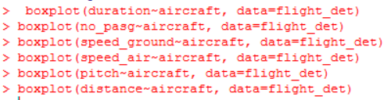

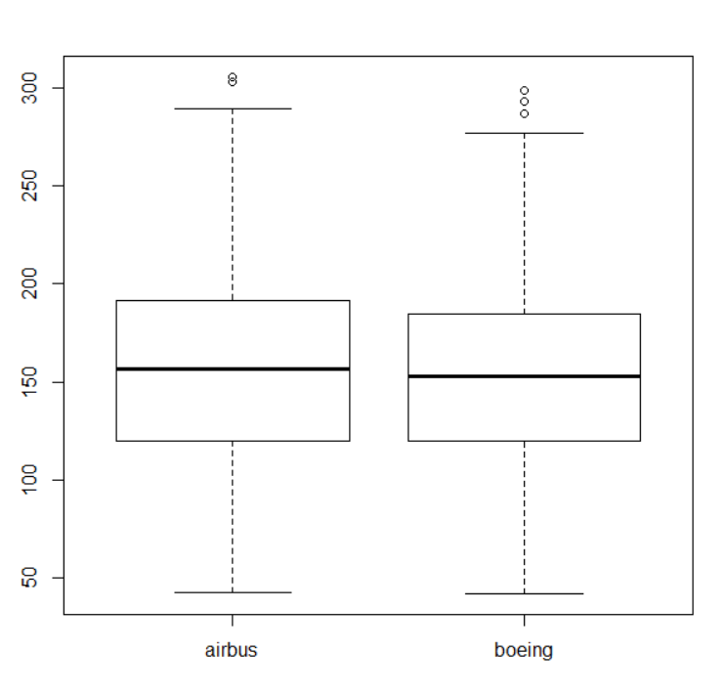 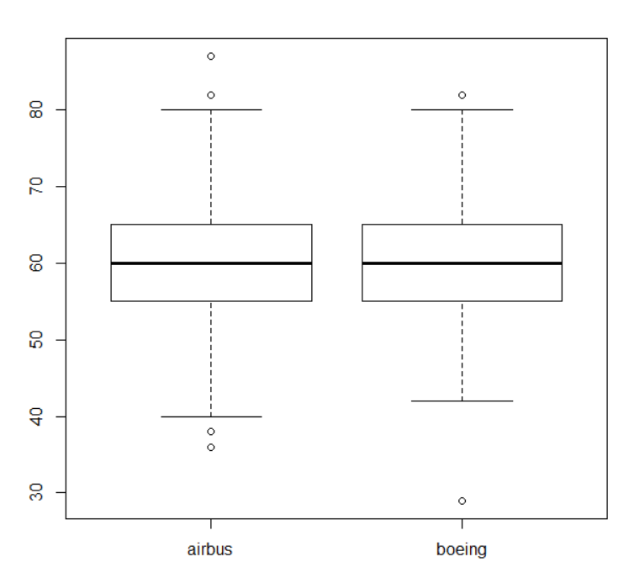

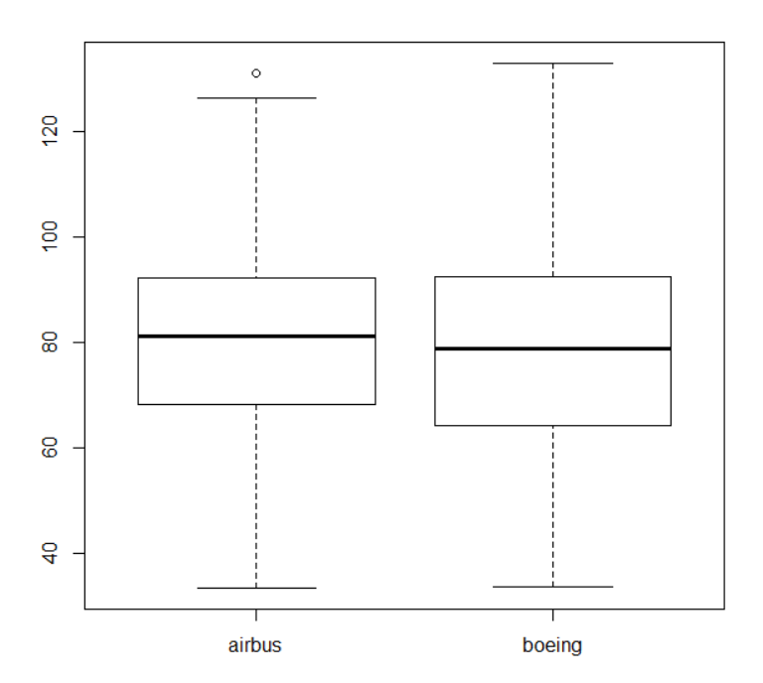 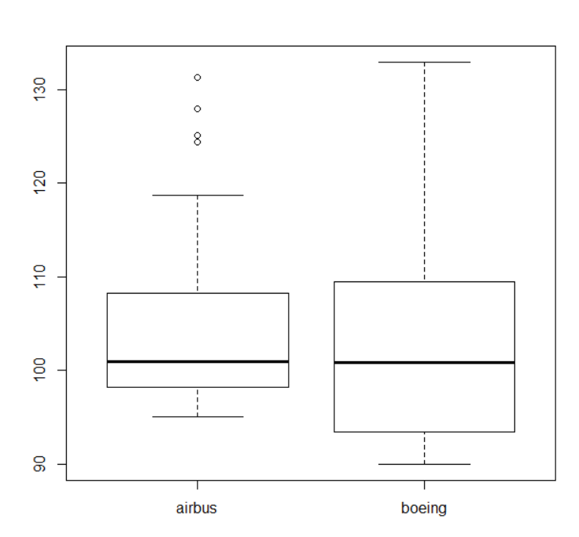

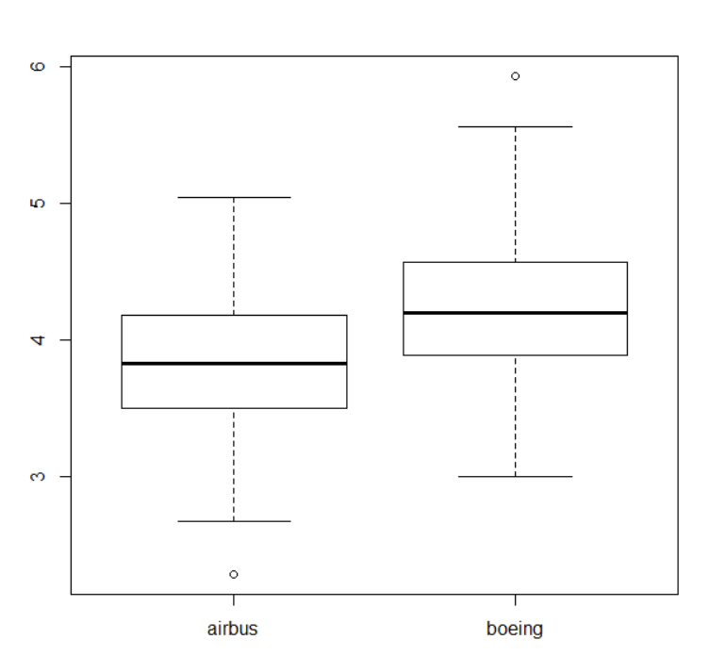 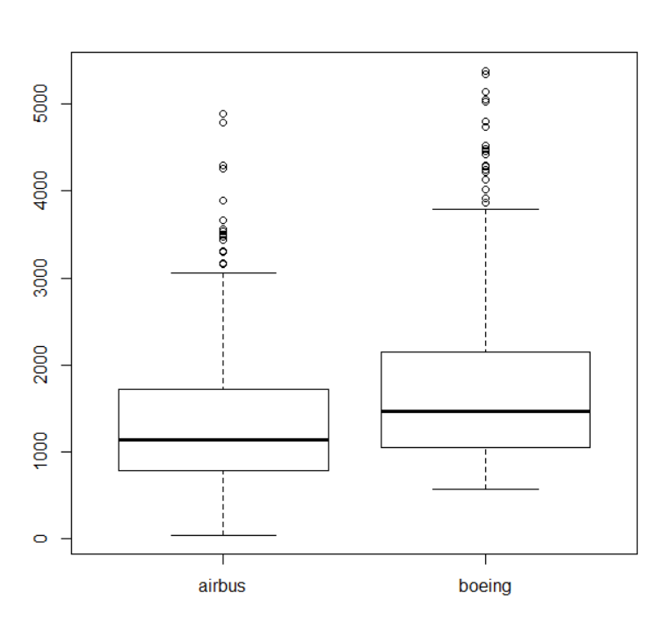

1. **Find correlation between the different measures**

measures <- flight_det[,-(1),drop=FALSE]

cor(measures,use = "complete.obs")

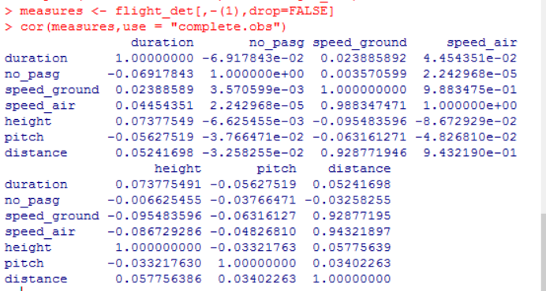

1. **Drop the speed_air column due to high correlation coefficient**

flight_analysis <- flight_det[,-(5),drop=FALSE]

dim (flight_analysis)

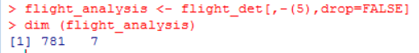

**CHAPTER - 3**

**Introduction:**

In this chapter we aim to model the data and arrive at the final equation supporting the models.

**R-Code:**

1. **Include speed_ground^2**

flight_analysis$sg2 = flight_analysis$speed_ground * flight_analysis$speed_ground

1. **Model**

model <- lm(distance~aircraft + no_pasg + speed_ground + sg2 + height -1, data = flight_analysis)

coefficients(model)

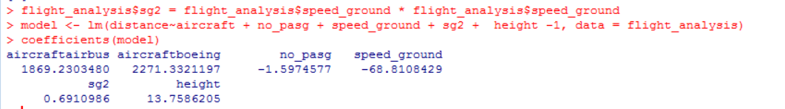

resid <-residuals(model)

1. **Plot the models**

plot(model)

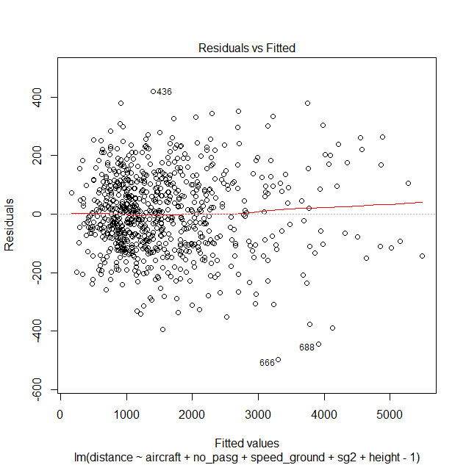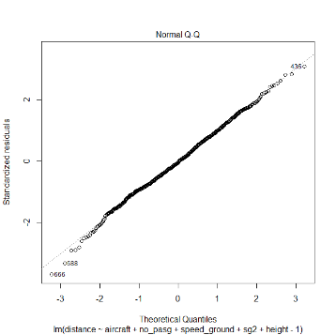

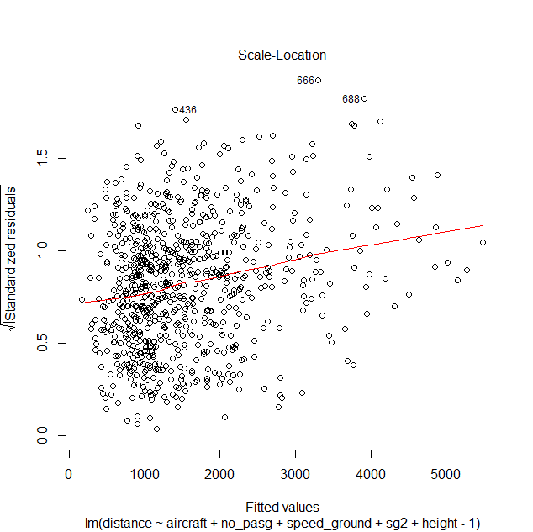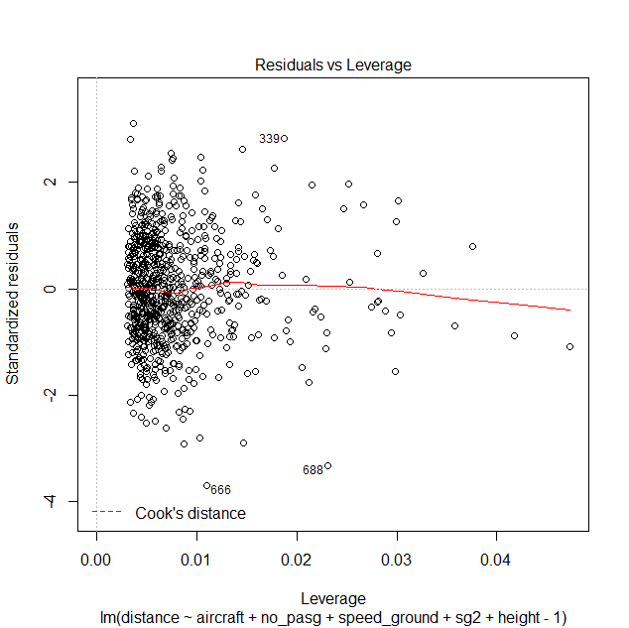

**Final Equations:**

Distance(Boeing) = 2271.3321 + 0.6911*speed_ground2 - 1.5975*no_pasg - 68.8108*speed_ground+ 13.7586*height

Distance(Airbus) = 1869.2304 + 0.6911*speed_ground2 - 1.5975*no_pasg - 68.8108*speed_ground+ 13.7586*height